# **CIS 36A :: Lab 1 - Java Fundamentals**

Student Name: Esmatullah Nickzad

## Task 1: Definitions & Concepts

**Instructions:** Answer the questions below in one sentence.

1. What is Java ***bytecode*** and how does it differ from ***machine code***?  
   => java bytecode serves as an intermediary representation between the high level java source code and the machine code,

Java bytecode in an intermediate platform independent code generated by the java compiler, designed for execution on a java virtual machine ( JVM) contrasting with machine code that is machine specific and executed directly by a computer CPU.

1. Write three reasons why you should learn Java?  
   => (1) Java is number one famous programming language, people use more in different industries nowadays.

(2) java’s “ write once, run anywhere” principle allows java programs to be executed on different platforms without modification, enhancing portability and reducing development complexities.

(3) I chose because its similar to C and C++ so by learning java I also learn C and C++.

## Task 2: Understanding Programming

**Instructions:** Answer each question below. Try to understand and explain the code. You do not need to test any code with an IDE. **Do not put an IDE code screenshot.**

1. **Exercise 26:** Use **indentation**, **spacing**, and **multiple lines** to make the following program more readable.

|  |
| --- |
| /* This program computes and prints the sum of the first 10 positive integers */ class SumFrom1To10{public static void main(String[] args){int sum,i;sum=0;for(i=1;i<=10;i++)sum=sum+i;System.out.println("The sum 1+2+...+10 is "+sum);}}  **Corrected version:**  Class SumFromTo10 {  Public static void main (String [] args {  int sum, i;  Sum = 0;  for (I = 1; i<= 10; i ++) {  Sum = sum + i ;  }  System.out.println(“The sum 1+2...+10 is “+ sum);  }  } |

1. **Exercise 27:** Suggest more appropriate names for the class and the variables in the following program.   
   Color your changes.

|  |
| --- |
| /* This program converts Fahrenheit to Celsius. */ class converter {  public static void main(String[] args) {  double x, xx;  x = 62;  xx = (x-32) * 5.0/9.0;  System.out.print(x + " degrees Fahrenheit is ");  System.out.println(xx + " degrees Celsius.");  } }  **Answer:**  Class FahrenheitToCelsiusConverter {  public static void main (String [] args ) {  double fahrenheitInput, CelsiusResult;  fahrenheitInput = 62;  celsiusResult = (fahrenheitInput – 32) * 5.0/9.0;  Systtem.out.println(fahrenheitInput + “degrees Fahrenheit is“);  System.out.println(celsiusResult + “ degrees Celsius”);  }  } |

## Task 3: Programming Exercises

**Instructions:** Use any Sublime Text to write and execute below exercises from the book. Attach screenshots of your **source code** and t**est run of the code in the console**. Screenshot only what is relevant. Make sure to create separate java files for each exercise. Reference to textbook Chapter 1 Exercises: Page 39-41. I have typed all of the questions. So you should be able to do them without the book.

**Sample Screenshot that shows my work in below ­­­­­­­­🡪**

1_ Write a Java program that prints three lines of information about you such as your name, major, hobbies, etc.… Name this program as **AboutMe.java**

**2_ ASCII Art:** Use System.out.println() to write a program that prints a shape or a face, or a simple picture.

1. **Try This 1-2 - GalToLit (Page: 27):** Write a program that converts gallons to liters and prints a statement that says: **X** gallons is **XX** liters.

You should have a double variable named **gallons** that stores a value such as 10 and another variable named **liters** that stores the calculation from the conversion. The conversion rate: 1 gallon = 3.7856 liters

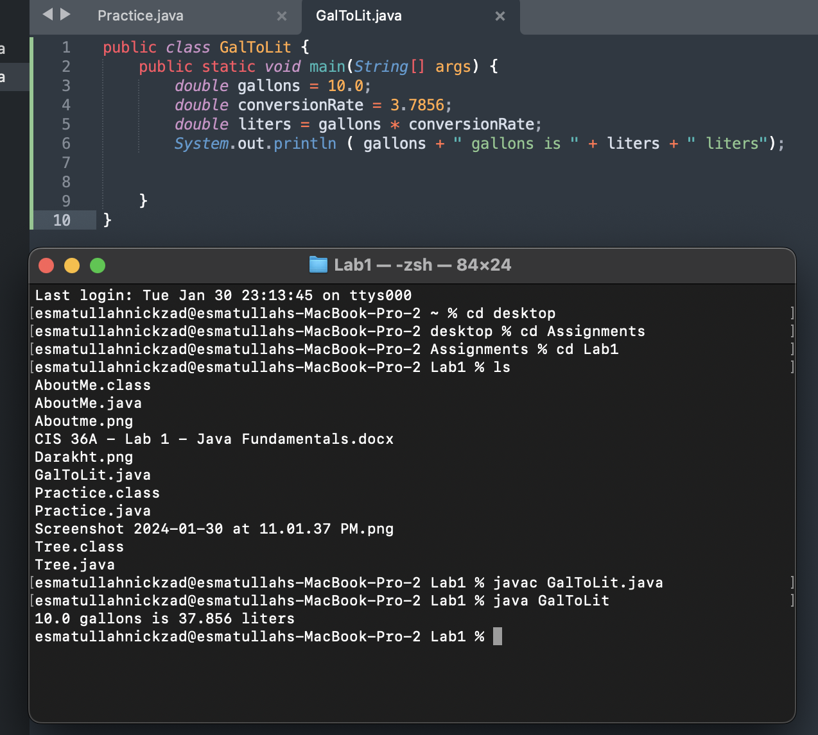

1. Rewrite the GalToLit program so that it takes gallons as user input and prints out the litters. You can import and use the Scanner class.

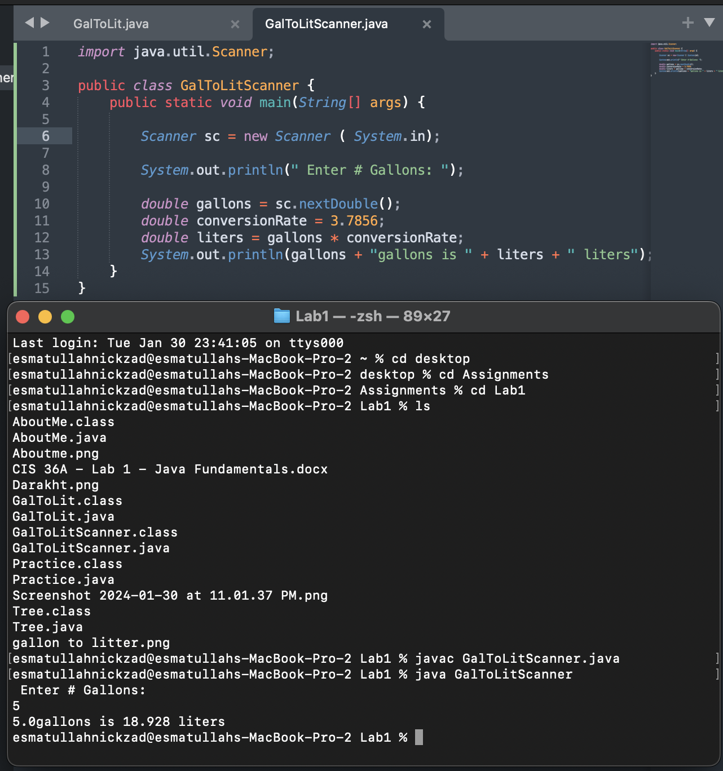

1. **Exercise 13:** Mars’s gravity is about 37 percent of earth’s. Write a program that computes and prints your effective weight on Mars.

1. **Exercise 30 (Modified):** Write a program that prints out the first 10 squares (1, 4, 9, 16,...,100), one per line. Use a for loop.

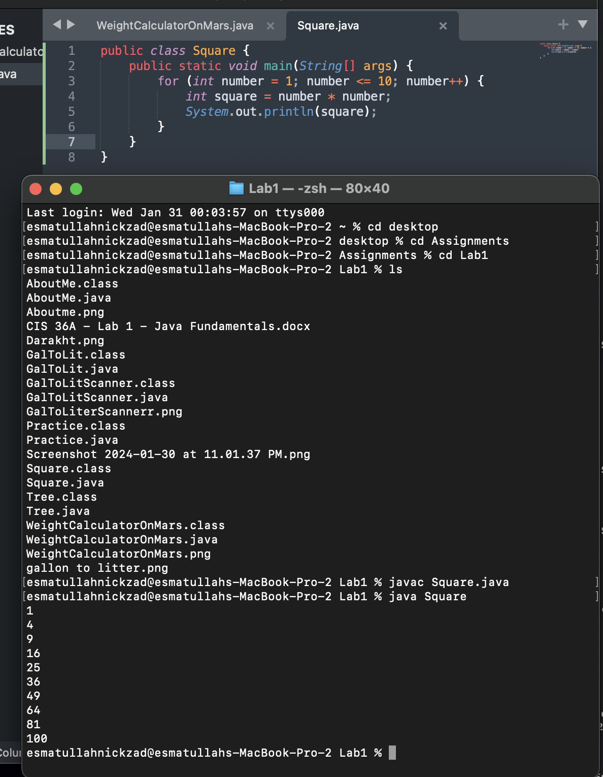

1. Write a program that prints the sum of the first 10 natural numbers (1 + 2 + 3 + ... + 10).   
   Use an accumulator variable, **sum**, and a loop.

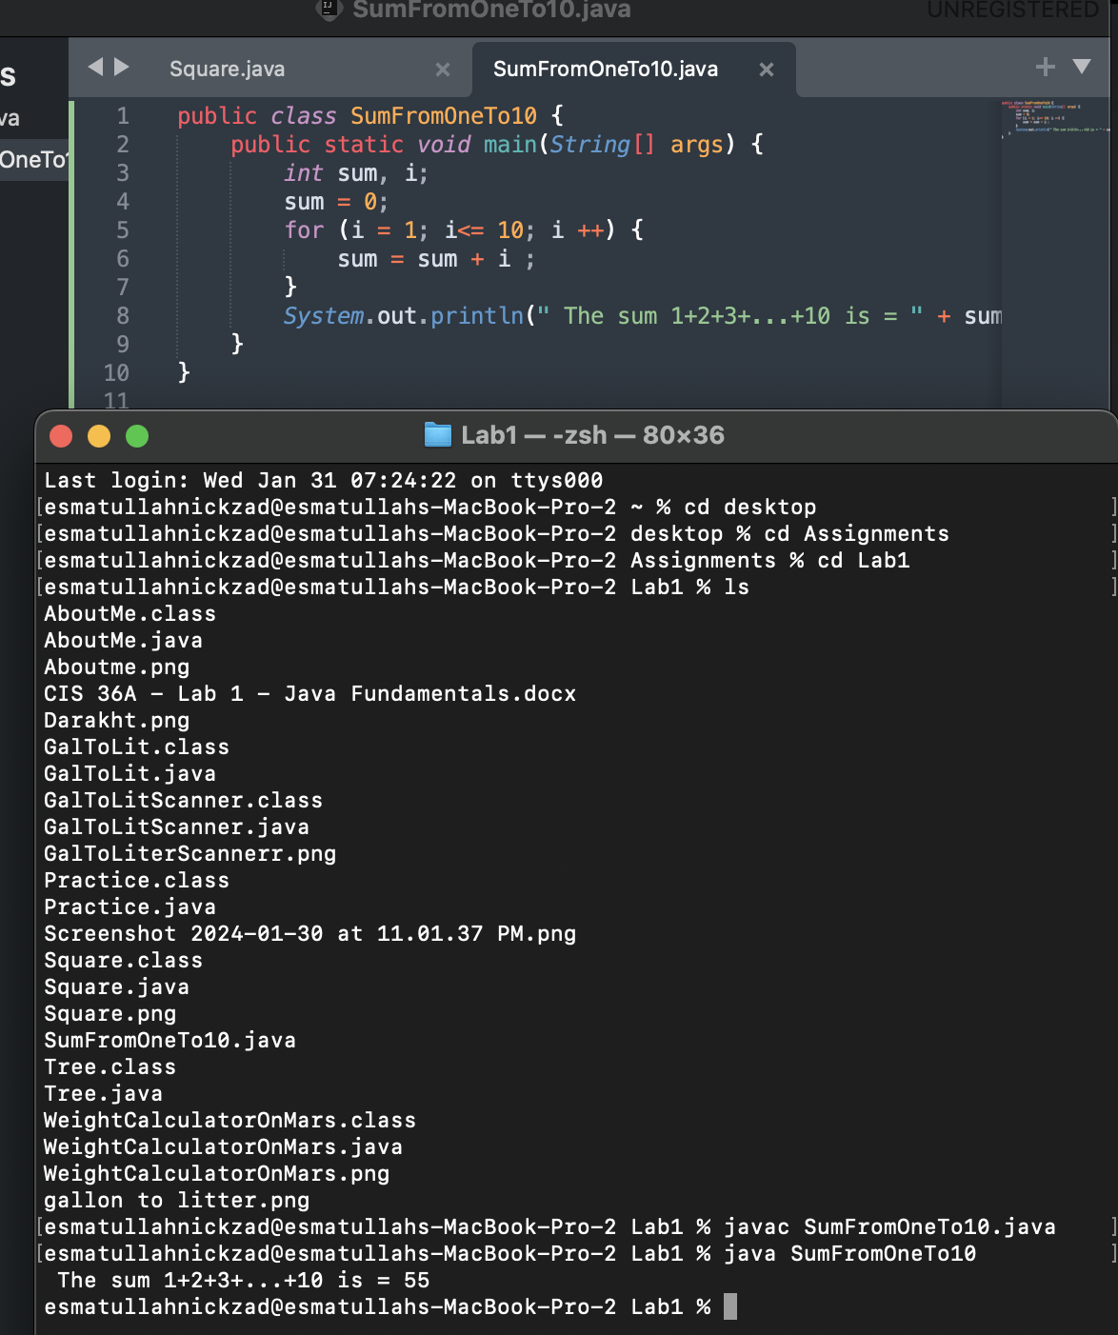

**Task 4: Programming Application**

**Input-Process-Output:** Similar to GalToLit, write a program that takes some user input, processes this input to a new value and prints it on the console.   
(For Example: Ask for the user's age as an integer and print if they can vote. You must be 18 years old to vote). Come up with your own example.

